
E-Commerce Database System

Database Design and Development
Project - 2
Name: Rojan Chandra Poudel
Table of Contents
Project Scenario: E-Commerce Retail Platform 3
Introduction 3
Enhanced Entity Relationship Diagram (EERD) 4
Business Rules 5
Cardinalities 5
Relational Schema & Normalization 6
Functional Dependencies (FDs) 7
Normalization 9
First Normal Form (1NF) 9
Second Normal Form (2NF) 9
Third Normal Form (3NF) 9
SQL Server DDL & DML 10
SQL Queries 21
NoSQL (MongoDB) 27
E-commerce Database 27
Product Collection 28
Records 28
MongoDB script 29
Concurrency & Transactions 30
Example Scenario 30
References 31

Project Scenario: E-Commerce Retail Platform
The proposed system we chose is an e-commerce retail database designed to support online shopping, including customer registration, product browsing, inventory management and shipment tracking. Given the large volume of transactions common in e-commerce sectors, the database must maintain high integrity and reliability, while also being able to expand (Connolly & Begg 2015).
Modern e-commerce systems need varied relational structures as well as flexible NoSQL components to manage diverse product attributes and large quantities of data (Ben Lhoucine, Tatane & Dahr 2026; Osiichuk & Zagorodna 2026).

Introduction
This report represents the design and implementation of an E-commerce Database system. Which has been developed for our group assessment. It supports core business operations, including customer management, product catalog, cart handling, order processing, payment recording, shipment tracking and inventory control. The database was modeled with an Enhanced Entity Diagram Consisting of 10 entities (Connolly & Begg, 2020).
This project covers EERD development, normalization, SQL implementation, sample queries, a NoSQL demonstration and explanations of concurrency. The group members completed the work together, supported by documented meetings and clearly assigned responsibilities.

Enhanced Entity Relationship Diagram (EERD)
An EERD diagram is a visual representation of the objects in the system showing how they can relate with each other. And how one can depend on another to make the system work. The EERD Diagram we made for our project is given below,
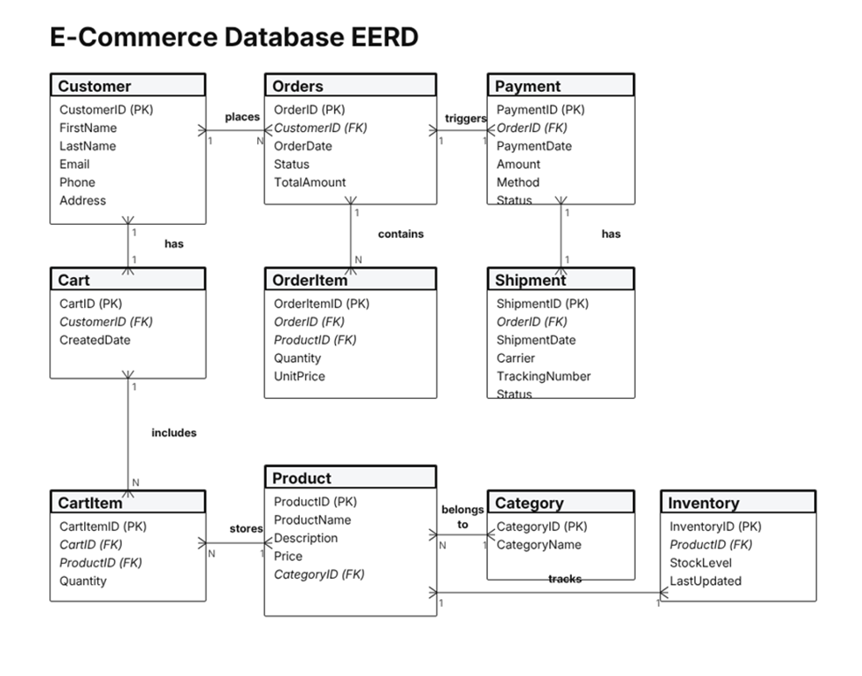
This designed EERD diagram has 10 entities. Which are, Customers, Orders, Payment, Shipment, Cart, CartItem, OrderItem, Product, Category and inventory. All the entities have their own attributes, primary keys, foreign keys and relationship names. Crow’s food notation is also given to show the cardinalities, and all many-to-many relationships are shown by using associative entities (Elmasri & Navathe, 2016).

Business Rules
To align our EERD diagram for a good e-commerce system, necessary use of business logic is compulsory. The business rules are set so that the system can operate in a set of rules that can keep the system operational and stable. The business rules used to design the EERD diagram are,
- Customers can place many orders,
- Customer has one cart,
- An order can have many order items,
- An order triggers one payment,
- An order has one shipment,
- A cart can have many cart items,
- A product belongs to one category,
- A product tracks one inventory record,
- A product can store many cart items,
- A product can fulfill many order items.

Cardinalities
To show the relationship between entities we have used cardinalities. The relation cardinalities are given below,
Customers - OrderItem 1:M
Orders - Payment 1:1
Orders - Shipment 1:1
Product - OrderItem 1:M
Product - CartItem 1:M
Category - Product 1:M
Product - Inventory 1:1
Cart - CartItem 1:M
By applying these cardinal rules, we can ensure clarity, consistency and alignment with E-commerce scenarios and real-world operations (Laudon & Traver, 2022).

Relational Schema & Normalization
We have used Relational Data structure schema for the database Design. The data scheme has been used to normalize the relations in the table for every attribute, primary keys, foreign keys and constraints. To develop a well-suited model for SQL this step step is very important (Connolly & Begg, 2020).
The relational schema derived from all 10 entities of E-commerce EERD is given below,
Customer
Customer(CustomerID, FirstName, LastName, Email, Phone, Address)
PK - CustomerID
Orders
Orders(OrderID, CustomerID, OrderDate, Status, TotalAmount)
PK - OrderID
FK- Customer > Customer.CustomerID
Payment
Payment(PaymentID, OrderID, PaymentDate, Amount, Method, Status)
PK - PaymentID
FK - OrderID > Orders.OrderID
Shipment
Shipment(ShipmentID, OrderID, ShipmentDate, Carrier, TrackingNumber, Status)
PK - ShipmentID
FK - OrderID > Orders.OrderID
Cart
Cart(CartID, CustomerID, CreatedDate)
PK - CartID
FK- CustomerID > Customer.CustomerID
CartItem
CartItem(CartItemID, CartID, ProductID, Quantity)
PK - CartItemID
FK - CartID > Cart.CartID
FK - ProductID > Product.ProductID
OrderItem
OrderItem(OrderItemID, OrderID, ProductID, Quantity, UnitPrice)
PK - OrderItemID
FK - OrderID > Orders.OrderID
FK - ProductsID > Product.ProductID
Product
Product(ProductID, ProductName, Description, Price, CategoryID)
PK - ProductID
FK - CategoryID > Category.CategoryID
Category
Category(CategoryID, CategoryName)
PK - CategoryID
Inventory
Inventory(InventoryID, ProductID, StockLevel, LastUpdated)
PK - InventoryID
FK - ProductID > Product.ProductID

Functional Dependencies (FDs)
Functional dependencies are used to describe how attributes are going to depend on keys (Elmasri & Navathe, 2016).
Customer,
CustomerID > FirstName, LastName, Email, Phone, Address
Orders,
OrderID > CustomerID, OrderDate, Status, TotalAmount
CustomerID does not determine OrderID (many orders per customer)
Payment,
PaymentID > OrderID, PaymentDate, Amount, Method, Status
Shipment,
ShipmentID > OrderID, ShipmentDate, Carrier, TrackingNumber, Status
Cart
CartID > CustomerID, CreatedDate
CustomerID > CartID (1:1 relationship)
CartItem
CartItemID > CartID, ProductID, Quantity
OrderItem
OrderItemID > OrderID, ProductID, Quantity, UnitPrice
Product
ProductID > ProductName, Description, Price, CategoryID
Category
CategoryID > CategoryName
Inventory
InventoryID > ProductID, StockLevel, LastUpdated

Normalization
Normalization is a method used to organize data. It helps the database to reduce duplicate storage and prevent errors. With the help of normalization, it is possible to reduce the amount of redundancy and maximise integrity (Date, 2019).

First Normal Form (1NF)
All the attributes in the table must meet 1NF. All the attributes are atomic and there are no repeating groups. Also, there are no multi values attributes.
With this we can eliminate repeating groups and multi valued fields in a single cell.

Second Normal Form (2NF)
The attributes need to meet 2NF because all the non-key attributes depend on the primary key. Also, there are associative entities in the database such as, OrderItem, CartItem. So single attribute PKs are a necessity to avoid practical dependencies.

Third Normal Form (3NF)
The tables also follow 3NF because there are no transitive dependencies. The CategoryName can only depend on the CategoryID. Also, inventory attributes only depend on InventoryID. Again, product attributes also depend on ProductID.
With this, the relational schema is completely normalized to 3NF. With this the database can expect efficient storage, reduced redundancy and better performance (Coronel & Morris, 2018).

SQL Server DDL & DML
According to the EERD all the tables are created inside SQL Server Management System to create the SQL database server. All the table codes to construct the tables and the insert statements to put data into the tables are given below,
CUSTOMER TABLE
CREATE TABLE Customer (
CustomerID INT IDENTITY(1,1) PRIMARY KEY,
FirstName VARCHAR(50) NOT NULL,
LastName VARCHAR(50) NOT NULL,
Email VARCHAR(100) UNIQUE NOT NULL,
Phone VARCHAR(20),
Address VARCHAR(255)
);

INSERT INTO Customer (FirstName, LastName, Email, Phone, Address) VALUES
('Alice', 'Nguyen', 'alice@example.com', '0412345678', 'Sydney'),
('Ben', 'Patel', 'ben@example.com', '0498765432', 'Melbourne'),
('Chloe', 'Smith', 'chloe@example.com', '0400111222', 'Brisbane'),
('Daniel', 'Lee', 'daniel@example.com', '0422333444', 'Perth'),
('Emma', 'Brown', 'emma@example.com', '0433555666', 'Adelaide');
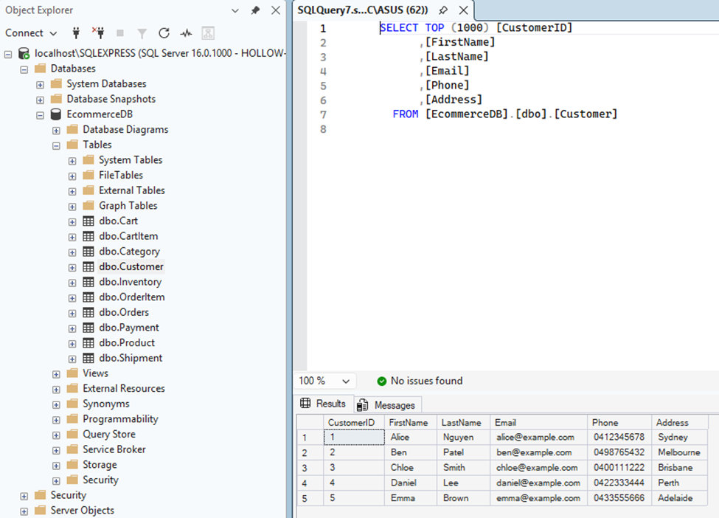
CATEGORY TABLE
CREATE TABLE Category (
CategoryID INT IDENTITY(1,1) PRIMARY KEY,
CategoryName VARCHAR(100) NOT NULL
);

INSERT INTO Category (CategoryName) VALUES
('Electronics'),
('Accessories'),
('Audio'),
('Home Appliances'),
('Gaming');
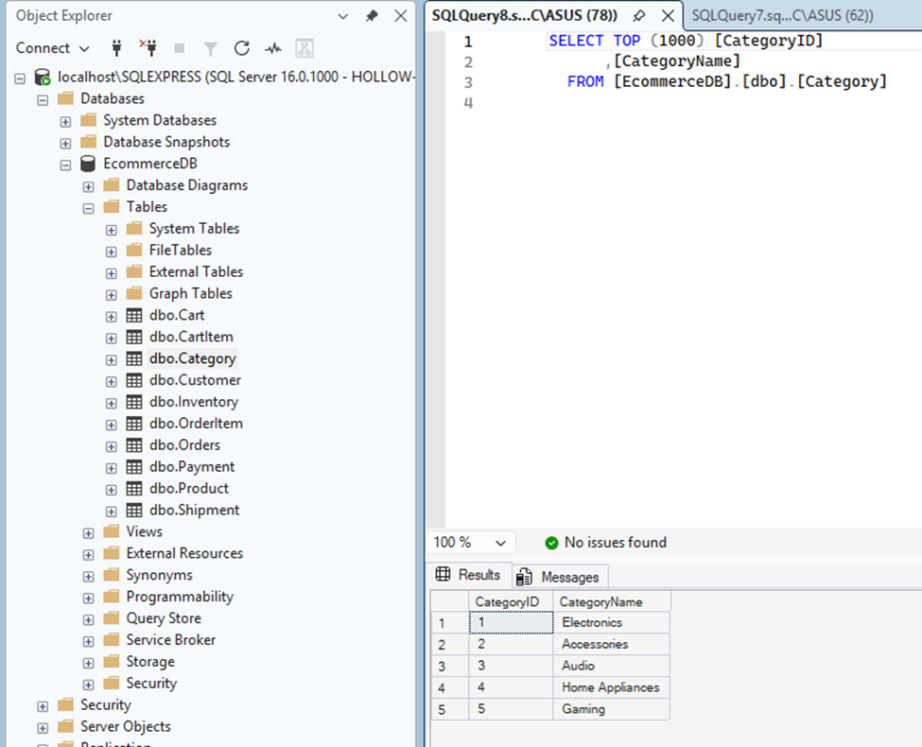
PRODUCT TABLE
CREATE TABLE Product (
ProductID INT IDENTITY(1,1) PRIMARY KEY,
ProductName VARCHAR(100) NOT NULL,
Description VARCHAR(255),
Price DECIMAL(10,2) NOT NULL,
CategoryID INT NOT NULL,
FOREIGN KEY (CategoryID) REFERENCES Category(CategoryID)
);

INSERT INTO Product (ProductName, Description, Price, CategoryID) VALUES
('Gaming Laptop', 'High performance laptop', 1899.00, 5),
('Wireless Mouse', 'Ergonomic wireless mouse', 49.99, 2),
('Noise Cancelling Headphones', 'Premium audio quality', 299.00, 3),
('Smartphone', 'Latest 5G smartphone', 1299.00, 1),
('Air Fryer', 'Healthy cooking appliance', 199.00, 4);
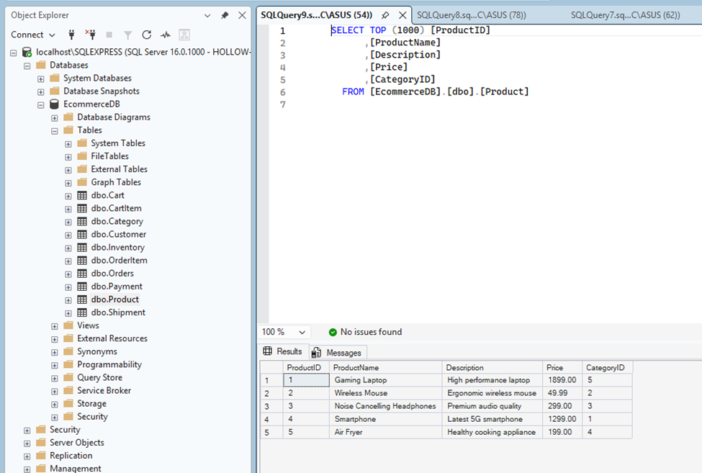
ORDERS TABLE
CREATE TABLE Orders (
OrderID INT IDENTITY(1,1) PRIMARY KEY,
CustomerID INT NOT NULL,
OrderDate DATE NOT NULL,
Status VARCHAR(50),
TotalAmount DECIMAL(10,2),
FOREIGN KEY (CustomerID) REFERENCES Customer(CustomerID)
);

INSERT INTO Orders (CustomerID, OrderDate, Status, TotalAmount) VALUES
(1, '2026-09-01', 'Completed', 1899.00),
(2, '2026-09-02', 'Pending', 49.99),
(3, '2026-09-03', 'Completed', 299.00),
(4, '2026-09-04', 'Shipped', 1299.00),
(5, '2026-09-05', 'Completed', 199.00);
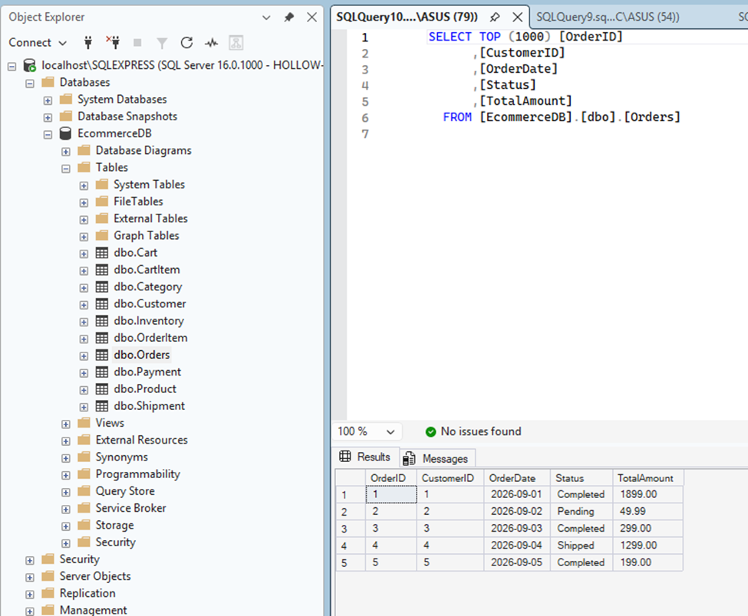
ORDERITEM TABLE
CREATE TABLE OrderItem (
OrderItemID INT IDENTITY(1,1) PRIMARY KEY,
OrderID INT NOT NULL,
ProductID INT NOT NULL,
Quantity INT NOT NULL,
UnitPrice DECIMAL(10,2) NOT NULL,
FOREIGN KEY (OrderID) REFERENCES Orders(OrderID),
FOREIGN KEY (ProductID) REFERENCES Product(ProductID)
);

INSERT INTO OrderItem (OrderID, ProductID, Quantity, UnitPrice) VALUES
(1, 1, 1, 1899.00),
(2, 2, 1, 49.99),
(3, 3, 1, 299.00),
(4, 4, 1, 1299.00),
(5, 5, 1, 199.00);
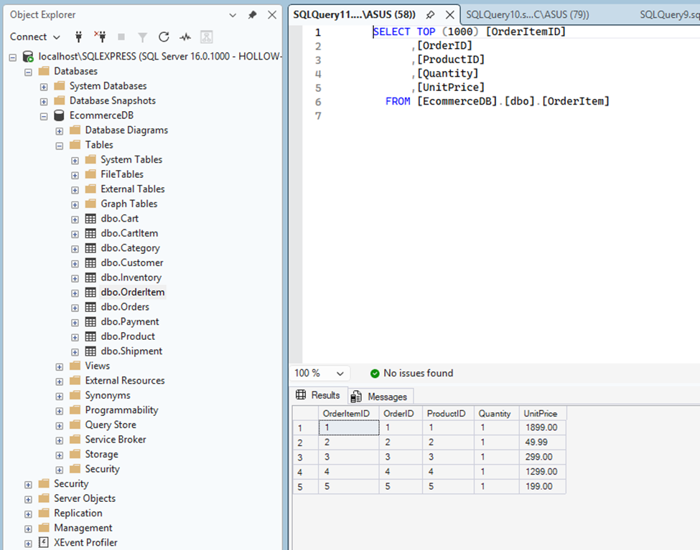
PAYMENT TABLE
CREATE TABLE Payment (
PaymentID INT IDENTITY(1,1) PRIMARY KEY,
OrderID INT NOT NULL,
PaymentDate DATE NOT NULL,
Amount DECIMAL(10,2) NOT NULL,
Method VARCHAR(50),
Status VARCHAR(50),
FOREIGN KEY (OrderID) REFERENCES Orders(OrderID)
);

INSERT INTO Payment (OrderID, PaymentDate, Amount, Method, Status) VALUES
(1, '2026-09-01', 1899.00, 'Credit Card', 'Paid'),
(2, '2026-09-02', 49.99, 'PayPal', 'Pending'),
(3, '2026-09-03', 299.00, 'Debit Card', 'Paid'),
(4, '2026-09-04', 1299.00, 'Credit Card', 'Paid'),
(5, '2026-09-05', 199.00, 'PayPal', 'Paid');
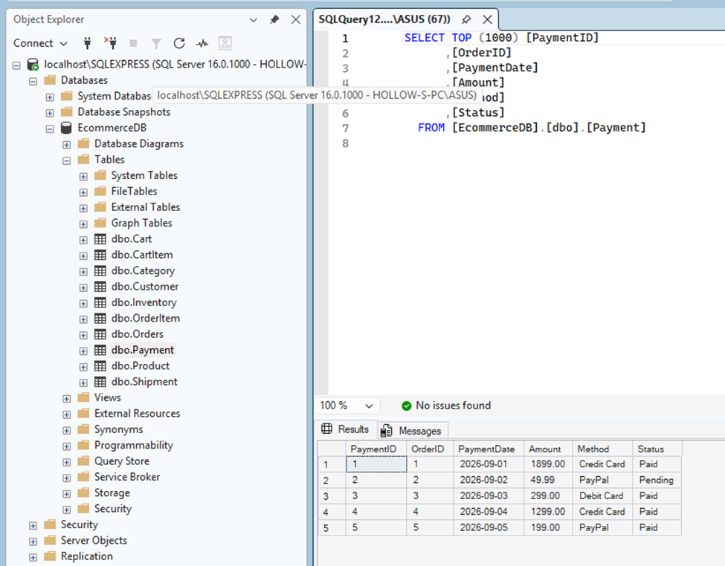
SHIPMENT TABLE
CREATE TABLE Shipment (
ShipmentID INT IDENTITY(1,1) PRIMARY KEY,
OrderID INT NOT NULL,
ShipmentDate DATE,
Carrier VARCHAR(100),
TrackingNumber VARCHAR(100),
Status VARCHAR(50),
FOREIGN KEY (OrderID) REFERENCES Orders(OrderID)
);

INSERT INTO Shipment (OrderID, ShipmentDate, Carrier, TrackingNumber, Status) VALUES
(1, '2026-09-02', 'DHL', 'DHL12345', 'Delivered'),
(2, NULL, 'FedEx', NULL, 'Pending'),
(3, '2026-09-04', 'UPS', 'UPS98765', 'Delivered'),
(4, '2026-09-05', 'DHL', 'DHL54321', 'Shipped'),
(5, '2026-09-06', 'Australia Post', 'AUS11111', 'Delivered');
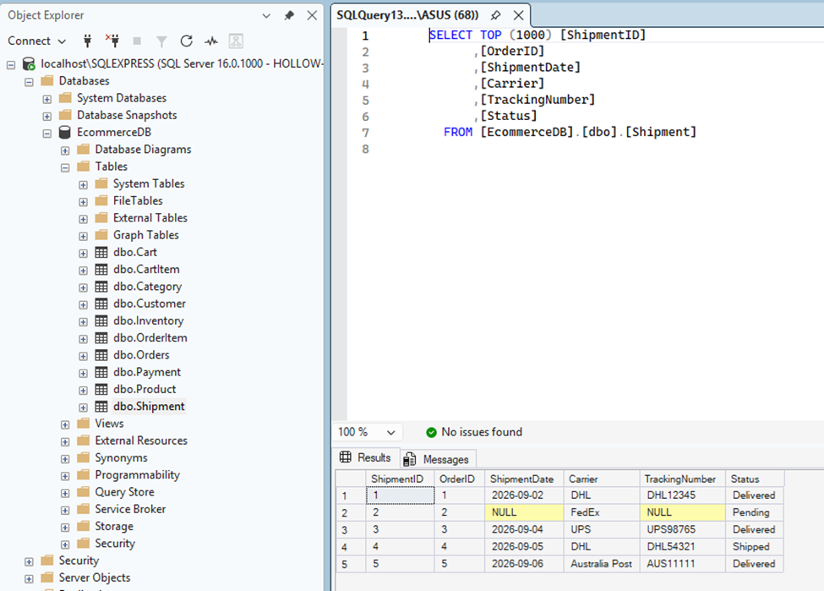
INVENTORY TABLE
CREATE TABLE Inventory (
InventoryID INT IDENTITY(1,1) PRIMARY KEY,
ProductID INT NOT NULL,
StockLevel INT NOT NULL,
LastUpdated DATE NOT NULL,
FOREIGN KEY (ProductID) REFERENCES Product(ProductID)
);

INSERT INTO Inventory (ProductID, StockLevel, LastUpdated) VALUES
(1, 10, '2026-09-01'),
(2, 50, '2026-09-02'),
(3, 30, '2026-09-03'),
(4, 20, '2026-09-04'),
(5, 40, '2026-09-05');
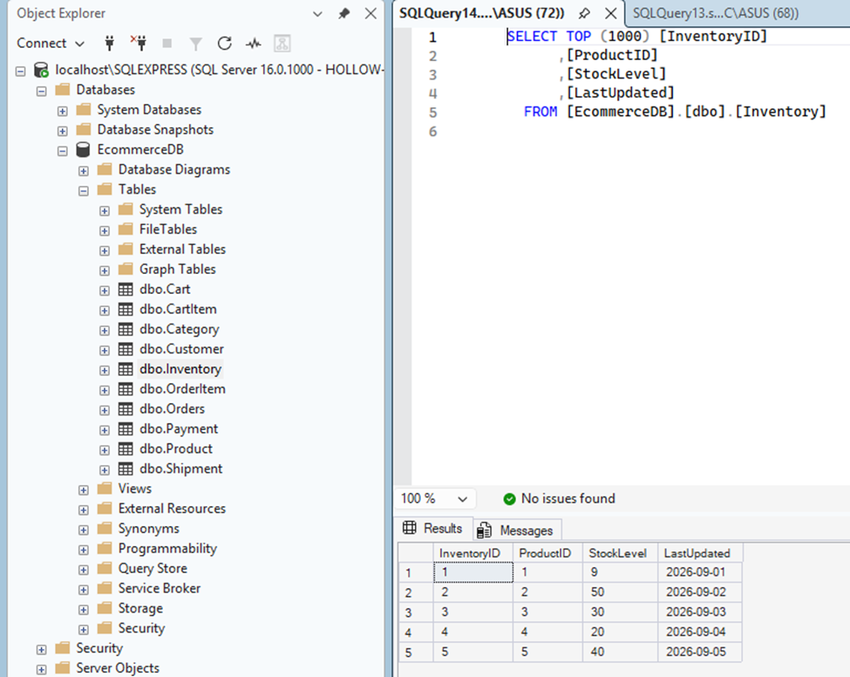
CART TABLE
CREATE TABLE Cart (
CartID INT IDENTITY(1,1) PRIMARY KEY,
CustomerID INT NOT NULL,
CreatedDate DATE NOT NULL,
FOREIGN KEY (CustomerID) REFERENCES Customer(CustomerID)
);

INSERT INTO Cart (CustomerID, CreatedDate) VALUES
(1, '2026-09-01'),
(2, '2026-09-02'),
(3, '2026-09-03'),
(4, '2026-09-04'),
(5, '2026-09-05');
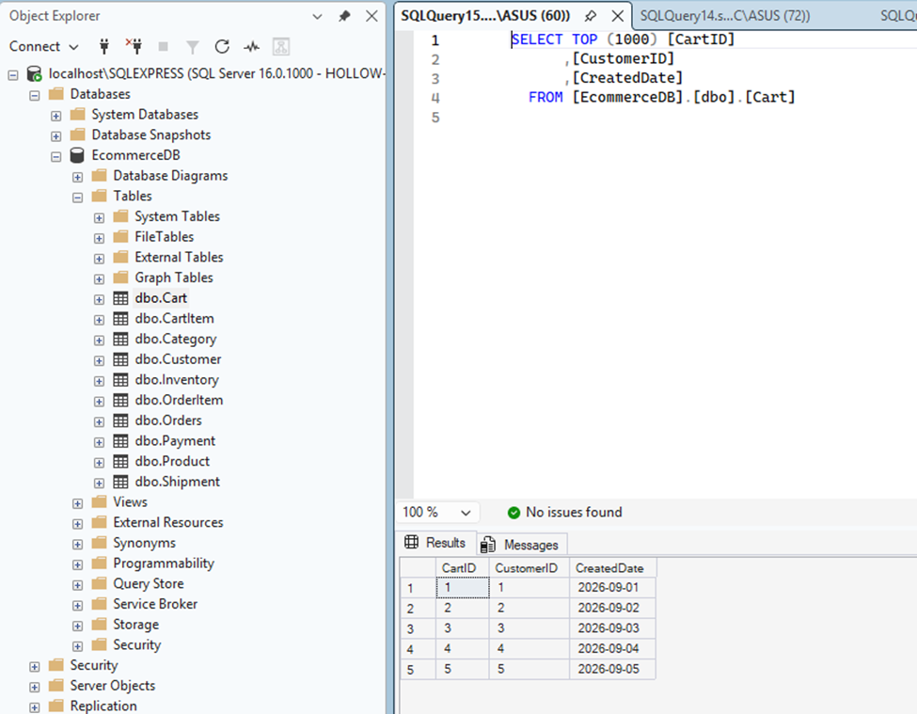
CARTITEM TABLE
CREATE TABLE CartItem (
CartItemID INT IDENTITY(1,1) PRIMARY KEY,
CartID INT NOT NULL,
ProductID INT NOT NULL,
Quantity INT NOT NULL,
FOREIGN KEY (CartID) REFERENCES Cart(CartID),
FOREIGN KEY (ProductID) REFERENCES Product(ProductID)
);

INSERT INTO CartItem (CartID, ProductID, Quantity) VALUES
(1, 2, 1),
(2, 3, 1),
(3, 4, 1),
(4, 1, 1),
(5, 5, 1);
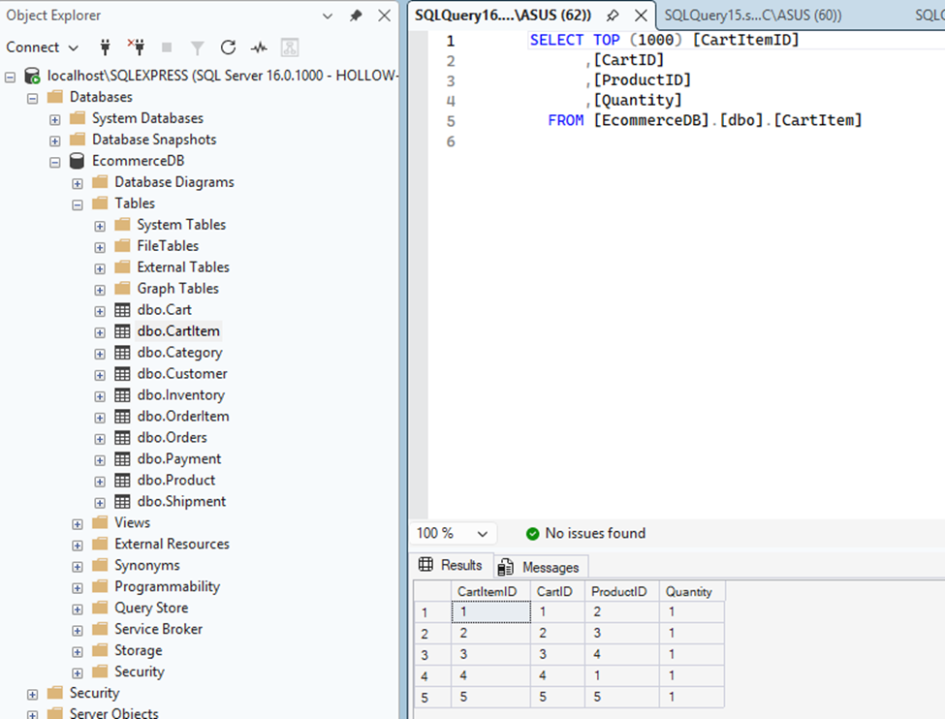

SQL Queries
An SQL query is a command that tells the database what we want. If we want to add data, update data, remove data or to organize them in a manner, then we can use SQL queries. The SQL queries ran into the E-commerce database is given below -
ORDER BY
SELECT ProductName, Price
FROM Product
ORDER BY Price DESC;
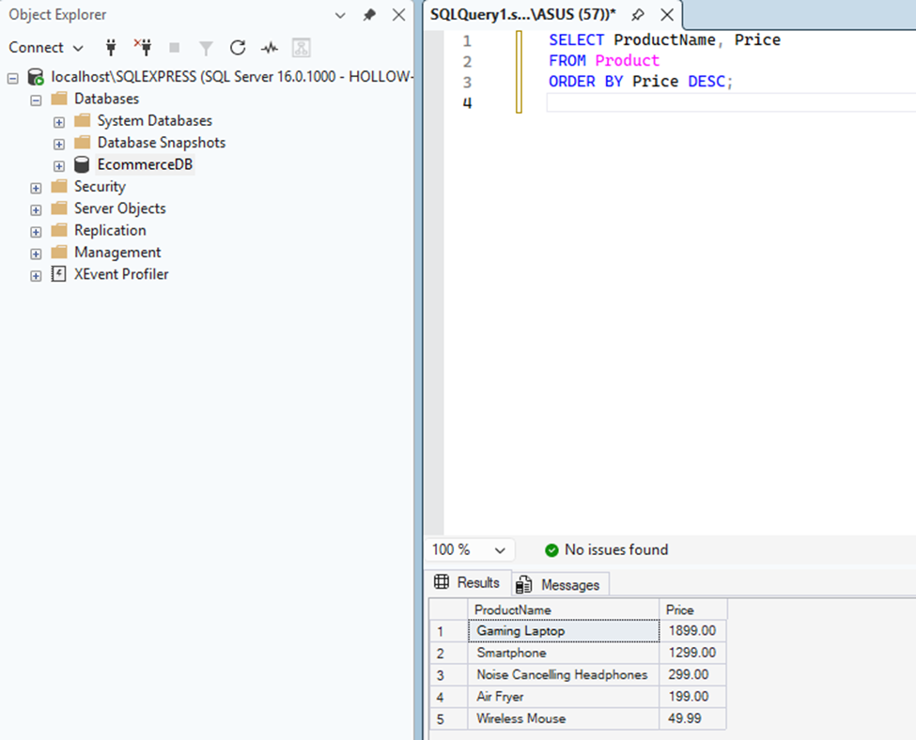
Like
SELECT *
FROM Product
WHERE ProductName LIKE '%Laptop%';
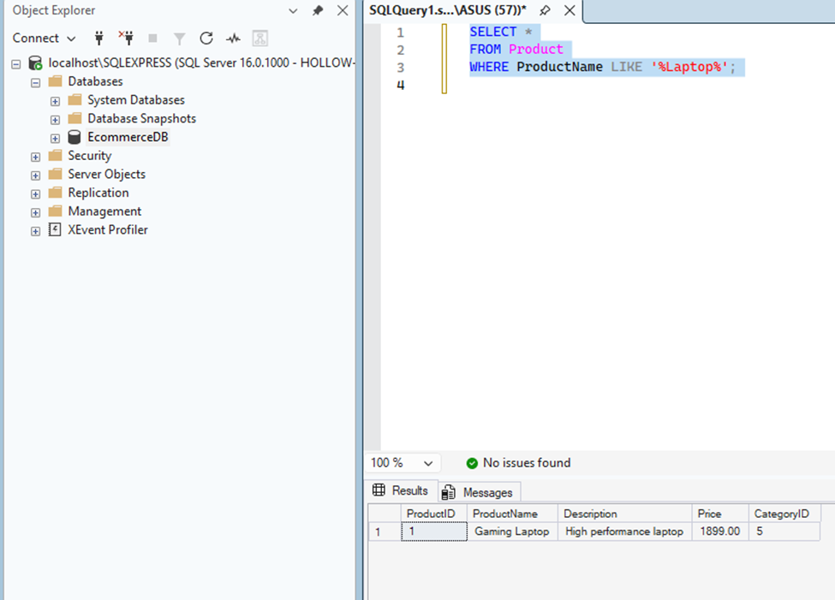
Aggregate
SELECT CustomerID, COUNT(*) AS TotalOrders
FROM Orders
GROUP BY CustomerID;
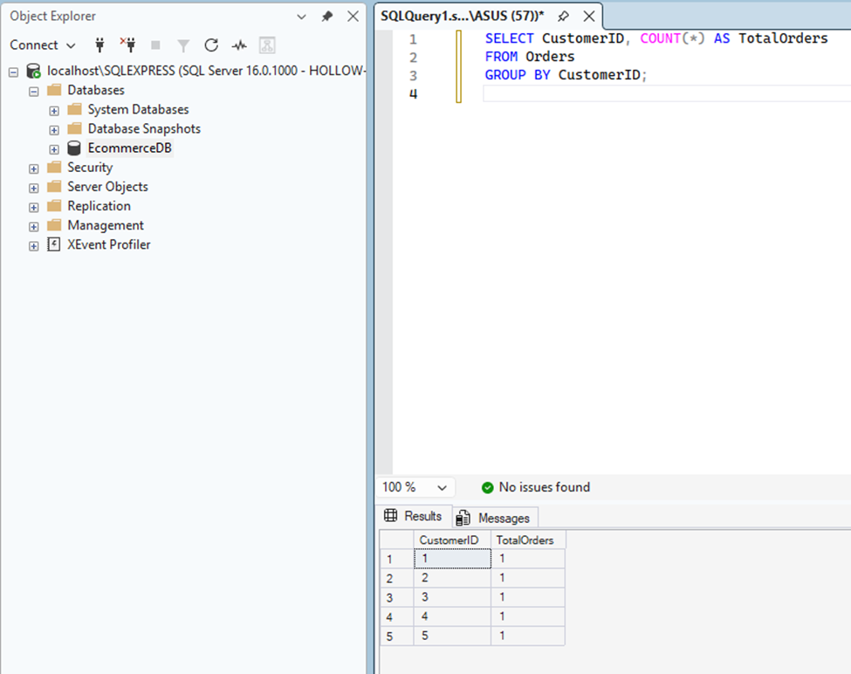
BETWEEN
SELECT *
FROM Orders
WHERE OrderDate BETWEEN '2026-09-01' AND '2026-09-05';
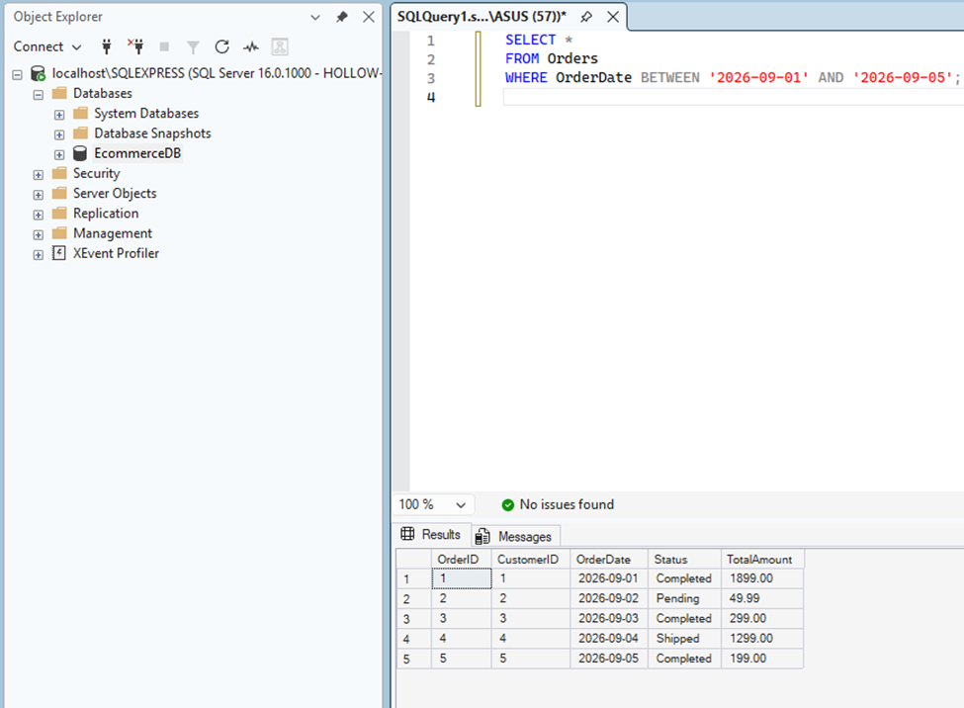
JOIN
SELECT c.FirstName, p.ProductName, oi.Quantity
FROM OrderItem oi
JOIN Orders o ON oi.OrderID = o.OrderID
JOIN Customer c ON o.CustomerID = c.CustomerID
JOIN Product p ON oi.ProductID = p.ProductID;
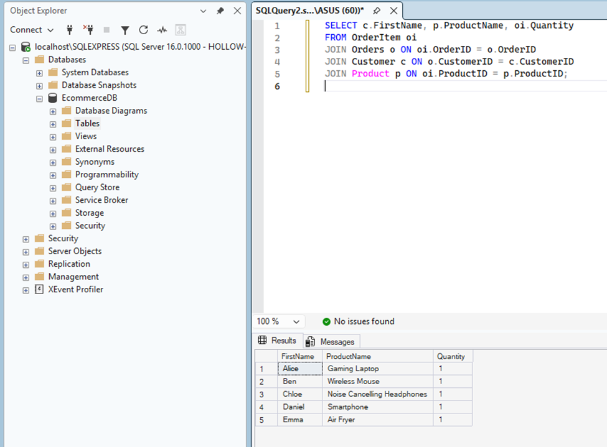
UPDATE
UPDATE Inventory
SET StockLevel = StockLevel - 1
WHERE ProductID = 1;
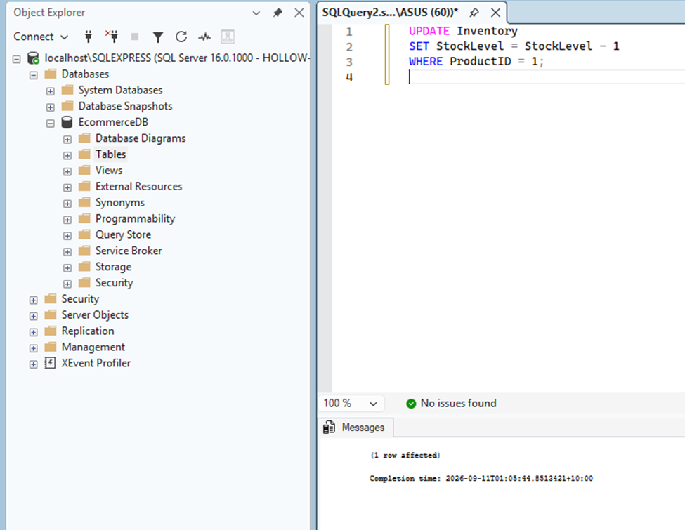

NoSQL (MongoDB)
MongoDB is a NoSQL database. It is very easy to operate and create a database server inside mongoDB. It stores the data in documents. Documents such as JSON files can be very flexible to work with.
In our E-commerce database project, we have constructed a NoSQL database with some project inputs to showcase the database. We have used MongoDB to make that server. The MongoDB server screenshot is given below-

E-commerce Database
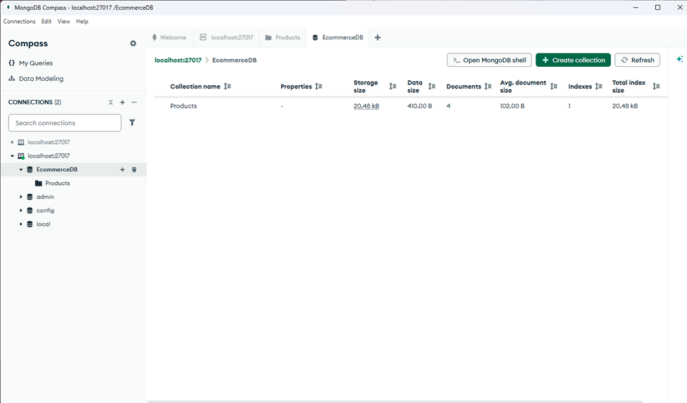

Product Collection
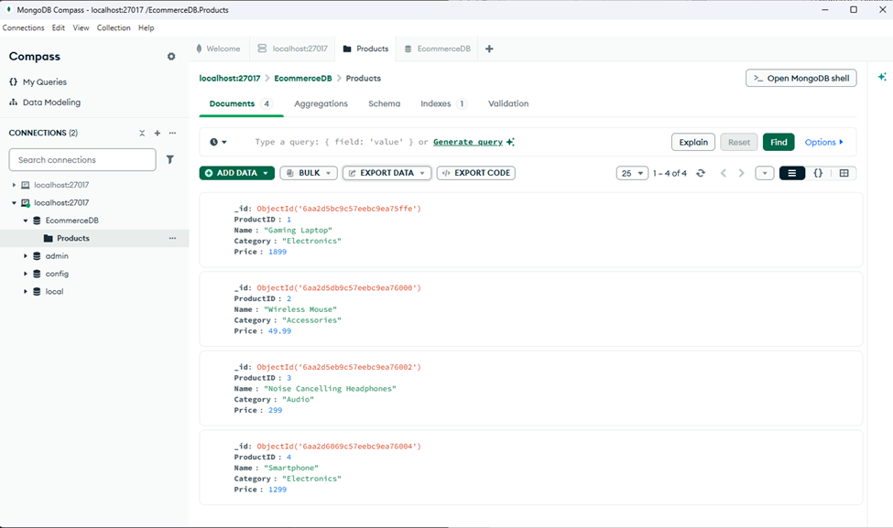

Records
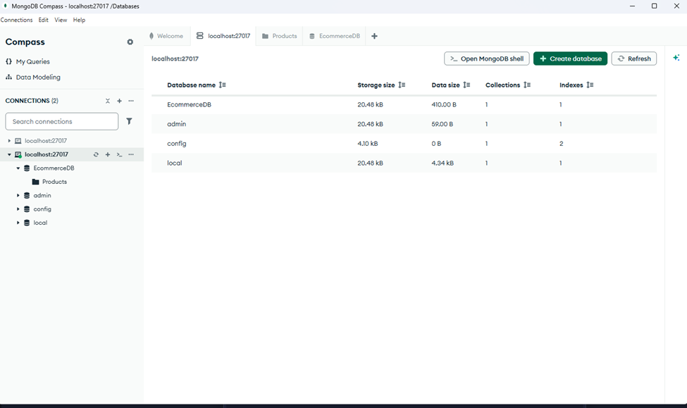

MongoDB script
The script used to insert the products into the database is given below-
use EcommerceDB;

db.Products.insertMany([
{ ProductID: 1, Name: "Gaming Laptop", Category: "Electronics", Price: 1899.00 },
{ ProductID: 2, Name: "Wireless Mouse", Category: "Accessories", Price: 49.99 },
{ ProductID: 3, Name: "Noise Cancelling Headphones", Category: "Audio", Price: 299.00 },
{ ProductID: 4, Name: "Smartphone", Category: "Electronics", Price: 1299.00 }
]);

db.Products.find().pretty();

Concurrency & Transactions
Concurrency and transactions are an essential part of the database management system because they help to keep the data accurate, secure and consistent when many users are working at the same time. When several operations run together, the system must make sure they do not interfere with each other in a harmful way. Without proper control data can become messy or even corrupted. Mainly, concurrency control works as a traffic manager inside the database, to make sure everything moves smoothly (Connolly & Begg, 2020).
Following this we have constructed our E-commerce database management server. Also the key points we took into consideration to make the system are-
Locking mechanism
Databases use locks to prevent two transactions from changing the same data at the same time. Which we have used in our database.
Deadlocks
During a deadlock two transactions wait for each other forever. Neither can continue, so the system must cancel one to continue. It is necessary.
ACID properties
This ensures the transaction behaves reliably. This keeps the data safe even when errors or crashes occur.
Transaction isolation levels
Isolation levels control how much information one transaction can take from another. This has a risk of inconsistent reading.
How SQL server prevents inconsistent reads
SQL servers use row versioning and isolation levels to stop the problem. It tries to balance the speed with corrections. Sometimes it can lead too much on one side.
How MongoDB handles atomic operations
MongoDB ensures atomicity at the document level. With this all the changes happen together inside a single document. However, it can be slow when operating multiple documents at the same time.

Example Scenario
In an e-commerce system, concurrency control is extremely important. The platform must prevent double payments, overselling inventory, or updating the wrong order when many customers are buying items at the same time. With this error there is a risk for customers to be charged twice. Also, businesses do not want to sell items that are out of stock.

References
Connolly, T & Begg, C 2020, Database Systems: A Practical Approach to Design, Implementation, and Management, 6th edn, Pearson, London.
Coronel, C & Morris, S 2018, Database Systems: Design, Implementation, and Management, Cengage Learning, Boston.
Date, CJ 2019, An Introduction to Database Systems, 8th edn, Addison-Wesley, Boston.
Elmasri, R & Navathe, SB 2016, Fundamentals of Database Systems, 7th edn, Pearson, London.
Harrington, J 2016, Relational Database Design and Implementation, 4th edn, Morgan Kaufmann, Burlington.
Laudon, KC & Traver, CG 2022, E‑Commerce: Business, Technology, Society, 16th edn, Pearson, London.

